Lab 09.02 Python and Databases

Using databases

### Overview

Calling the sql commands in python

### Before the lab

Install the python package

pip install mysql-connector

You will need to have your mysql server up and running,

I would usually create the database and tables on the server and not through python.

In this lab I show you how to create the table and then perform the crud operations.

NOTE: The user name and password for your database in WAMP the default is root and blank,

I show you how to change it in the lecture.

You should make a new file for each of these tasks.

## Not usually done (create database and tables)

1. Create a database called datarepresentation using a python script

import mysql.connector

mydb = mysql.connector.connect(

  host="localhost",

  user="root",

  password=""

)

mycursor = mydb.cursor()

mycursor.execute("CREATE DATABASE datarepresentation ")

1. Create the table in the database with the command

import mysql.connector

mydb = mysql.connector.connect(

  host="localhost",

  user="root",

  password="",

  database="datarepresentation"

)

mycursor = mydb.cursor()

sql="CREATE TABLE student (id INT AUTO_INCREMENT PRIMARY KEY, name VARCHAR(255), age INT)"

mycursor.execute(sql)

## CRUD operations on a table, this is what you would normally do from an application

1. Insert data

import mysql.connector

db = mysql.connector.connect(

  host="localhost",

  user="root",

  password="",

  database="datarepresentation"

)

cursor = db.cursor()

sql="insert into student (name, address) values (%s,%s)"

values = ("Mary","Galway")

cursor.execute(sql, values)

db.commit()

print("1 record inserted, ID:", cursor.lastrowid)

1. View data

import mysql.connector

db = mysql.connector.connect(

  host="localhost",

  user="root",

  password="",

  database="datarepresentation"

)

cursor = db.cursor()

sql="select * from student where id = %s"

values = (1,)

cursor.execute(sql, values)

result = cursor.fetchall()

for x in result:

  print(x)

1. Update data

import mysql.connector

db = mysql.connector.connect(

  host="localhost",

  user="root",

  password="",

  #user="datarep",  # this is the user name on my mac

  #passwd="password" # for my mac

  database="datarepresentation"

)

cursor = db.cursor()

sql="update student set name= %s, age=%s  where id = %s"

values = ("Joe",33, 1)

cursor.execute(sql, values)

db.commit()

print("update done")

1. Delete

import mysql.connector

db = mysql.connector.connect(

  host="localhost",

  user="root",

  password="",

  #user="datarep",  # this is the user name on my mac

  #passwd="password" # for my mac

  database="datarepresentation"

)

cursor = db.cursor()

sql="delete from student where id = %s"

values = (1,)

cursor.execute(sql, values)

db.commit()

print("delete done")

Delete from student where id = 1;

## Put it into a file that can be used from another file (eg from your flask app)

import mysql.connector

class StudentDAO:

    db=""

    def __init__(self):

        self.db = mysql.connector.connect(

        host="localhost",

        user="root",

        password="",

        #user="datarep",  # this is the user name on my mac

        #passwd="password" # for my mac

        database="datarepresentation"

        )

    def create(self, values):

        cursor = self.db.cursor()

        sql="insert into student (name, age) values (%s,%s)"

        cursor.execute(sql, values)

        self.db.commit()

        return cursor.lastrowid

    def getAll(self):

        cursor = self.db.cursor()

        sql="select * from student"

        cursor.execute(sql)

        result = cursor.fetchall()

        return result

    def findByID(self, id):

        cursor = self.db.cursor()

        sql="select * from student where id = %s"

        values = (id,)

        cursor.execute(sql, values)

        result = cursor.fetchone()

        return result

    def update(self, values):

        cursor = self.db.cursor()

        sql="update student set name= %s, age=%s  where id = %s"

        cursor.execute(sql, values)

        self.db.commit()

    def delete(self, id):

        cursor = self.db.cursor()

        sql="delete from student where id = %s"

        values = (id,)

        cursor.execute(sql, values)

        self.db.commit()

        print("delete done")

studentDAO = StudentDAO()

## Test it

from zstudentDAO import studentDAO

#create

latestid = studentDAO.create(('mark', 45))

# find by id

result = studentDAO.findByID(latestid);

print (result)

#update

studentDAO.update(('Fred',21,latestid))

result = studentDAO.findByID(latestid);

print (result)

# get all

allStudents = studentDAO.getAll()

for student in allStudents:

  print(student)

# delete

studentDAO.delete(latestid)

## Result 1)

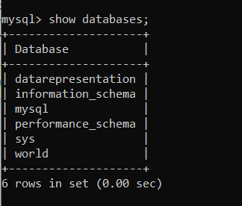

## Result 2 & 3)

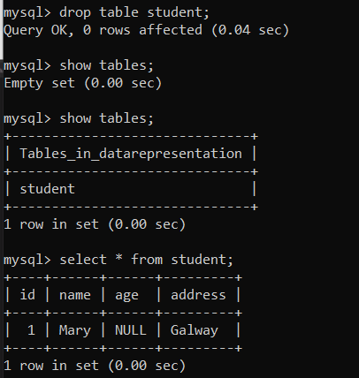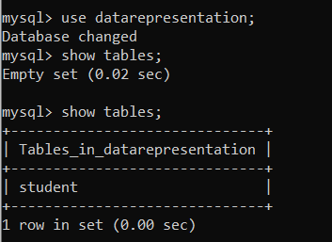

## Result 4)

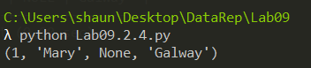

## Result 5)

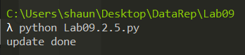

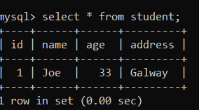

## Result 6)

